**Vocal Range: Mezzo-Soprano**

**Height: 5’2”**

**

**KALÉA**

**LEVERETTE**

**AEA**

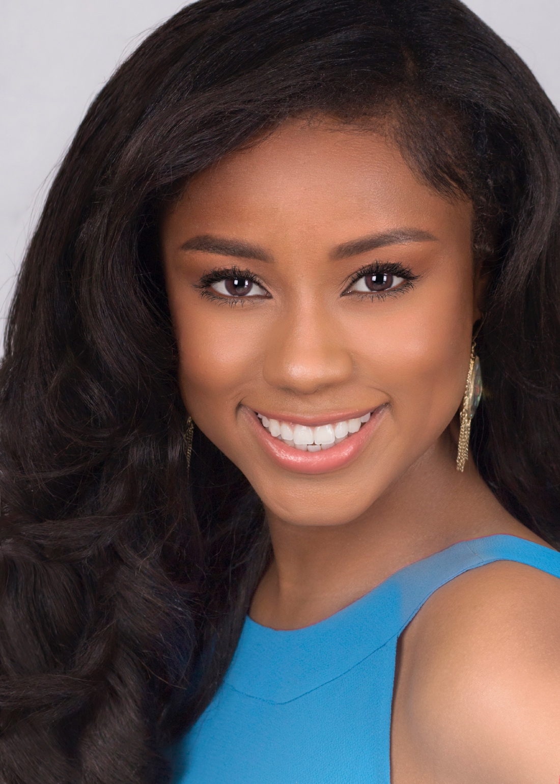

**CREDITS**

NEW YORK THEATRE

It’s Kind of a Funny Story Nia/Ensemble Papermill Playhouse/Universal Theatrical

**\*\*AEA developmental reading Dir. Jenny Koons**

NATIONAL TOURS

Hairspray Little Inez NETworks Presentations

**2021-2022 Dir. Jack O’Brien (Tour: Matt Lenz) Choreo. Jerry Mitchell (Tour: Michele Lynch)**

REGIONAL THEATRE

Once on This Island Ti Moune The Henegar Center

A Wrinkle in Time Meg Mountain Theatre Company

Grease Marty Alhambra Theatre and Dining

Beautiful: The Carole King Musical Little Eva/Shirelle Theatre By The Sea

Footloose Urleen Alhambra Theatre and Dining

Mamma Mia Lisa Actor’s Playhouse

Ain’t Misbehavin’Charlene/Swing Alhambra Theatre and Dining

Godspell Kaléa (Turn Back O Man) Alhambra Theatre and Dining

Bodyguard Swing (perf.) Theatre By The Sea

My Way Swing (perf. Woman#2) Theatre By The Sea

Elf the Musical Shawanda/Ensemble Alhambra Theatre and Dining

Big the Musical Mrs. Kopecki/Ensemble Alhambra Theatre and Dining

EDUCATIONAL

Suessical the Musical Gertrude McFuzz Virginia Theatre Association

The Wizard of OzScarecrow Virginia Theatre Association

Rosencrantz & Guildenstern are DeadGuildenstern The Hurrah Players

**TRAINING**

**PERSONAL SKILLS**

**Education**: Master’s (Public Health, George Washington University 2020); Bachelor’s (Biology and International Affairs Florida State University 2016)

**Acting and Voice**: Louis Sacco, James Calleri, Ryan Scott Oliver, Eugenie Bondurant, Aaron DeCicco, Julie Garnyé,

Dr. Joleen Neighbours, Mark Lubas

**Dance** (12+ years): Ballet, Jazz, Contemporary, Musical Theatre, Hip-Hop/Street

**Modelling**: Sessions Modeling Studio (Print, Commercial, Runway)

**Cheerleading** – 10 years (Stunts, Jumps, Choreography, Coaching), **Right and Left Splits**, **Modelling**, **Writing**- (published author*)*, Basic **Equestrian** Training, **Accents/Dialects** –American Southern, British, Southeast Asian, Some African, **Emergency Medical Care** (former certified EMT), Basic Archery (longbow), **Valid Passport**, **Valid Driver’s License**, Emergency Vehicle Driving experience , **Pageantry**- Miss St. John’s River USA 2019, Miss America Organization (Miss River City 2017, Miss Jacksonville 2018, Top 10 at Miss Florida)